

Software Engineering Department
Braude College
Eye Tracking Project Phase A

GitHub: Eye Tracking Project

Evaluation of Human-Oriented Canine Communication Using Eye Tracking Technology

Project code: 26-1-R-2

Supervisors: Dr. Julia Sheidin
Dr. Samah Idrees-Ghazawi

Yaniv Shtein - yaniv.shtein@gmail.com

Eden Moshe - Edenmoshe160299@gmail.com

Table of Contents

Abstract 4
1. Introduction 4
2. Background and Related Work 5
2.1. Breed-Specific Changes Observed in Dogs 5
2.2. Dog’s Facial Reenactment 6
2.3. Eye Tracking Technology 7
2.4. Facial Reenactment Using Eye-Tracking Technology 9
2.5. Summary 13
3. Research Process 13
4. Research Methodology 14
4.1. Stimuli 14
4.2. Procedure 15
4.3. Hypothesis 16
4.4. Experimental Parameters 16
4.5. Gaze Transitions Among AOIs 17
4.5.1. Gaze Transition Analysis and Matrix Generation: 17
4.5.2. Methodological Approach and Algorithm: 17
4.5.3. Understanding the Transition Matrix 18
4.5.3.1. Exploratory AOI Grouping Strategy 18
4.6. Tools and Technologies 19
4.7. Expected Challenges and Successes 19
4.7.1. Laboratory Setup, Licensing, and Environmental Control 19
4.7.2. Data Preparation and Manual Mapping 20
4.7.3. Participant Recruitment 21
4.7.4. Data Analysis and Algorithmic Implementation 21
GenAI Usage Discloser 21
References 21

Table of Acronyms

Acronym | Meaning or definition
AOI | Area of Interest
DAOI | Dynamic Area of Interest
CNN | Convolutional Neural Networks
FEIT | Facial Expression Identification Test
POI | Point of Interest
Tobii Pro Fusion | A screen-based eye tracker captures gaze data at speeds up to 250 Hz. This powerful research system supports analyses from fixation to saccade-based.
Tobii Pro Lab | Tobii Pro Lab is an eye-tracking software for behavior research.
TOI | Time of Interest
VPT | Visual Processing Therapy

Abstract
Understanding a dog's emotions is crucial for several reasons, and it plays a significant role in responsible dog ownership. However, which parts of the animal's body or face are more informative to the observer in recognizing emotion remains a poorly researched question. This research project aims to fill the gap by answering the following question: How can eye-tracking technology contribute to a deeper understanding of dogs and strengthen the connection between humans and dogs? To achieve this goal, we aspire to do research that uses eye-tracking technology and tracks the person's gaze using dog videos to understand if looking at a certain area improves the understanding of the dog's behavior. In this research, we aim to explore the feasibility of developing a system capable of identifying a dog's emotions through analysis of its movements and facial expressions.
We aim to develop a system that analyzes eye-tracking data from dog videos, and later use this data to create an algorithm that draws insights, such as how gaze fixation on certain areas or the dog's breed influences human perceptions of the dog's emotions. This project can provide crucial milestones for the future development of such a system, facilitating thorough preparation and planning of the process.

1. Introduction
Animals, and dogs in particular, employ facial expressions and body language to aid in maintaining their social structure with humans [Bloom & Friedman, 2013]. Those facial expressions of emotion offer important visual indicators for understanding others' emotional states and intentions [Guo & Shaw, 2015]. Being able to identify and comprehend a dog’s emotions through areas in their faces or bodies is crucial, since it can improve human communication with them [Eretová et al., 2024].
Dogs play various roles in human life, including companionship, rescue, therapy, and medical. Therefore, they have shown remarkable abilities in interpreting human gestures and cues, but understanding dogs' emotions through human-directed visual communication remains limited. Lack of knowledge about breed-specific traits or common dog behaviors can make it difficult to meet a dog's needs effectively.
Previous studies have delved into the emotional facial expressions of dogs, shedding light on their behavior and communication cues [Eretová et al., 2024; Correia‐Caeiro et al., 2023; Bloom & Friedman, 2013]. Moreover, research conducted by Correia-Caeiro et al. 2023 demonstrated that emotional expressions of dogs impact the duration of gaze directed towards particular facial regions in both children and adult humans, as evidenced in their previous study in 2020 [Correia-Caeiro et al., 2023; Correia-Caeiro et al., 2020]. Continuing this trajectory, we aim to investigate whether individuals' focus on specific regions of a dog's face and/or body helps in comprehending its emotions. Given the challenge of precisely determining which part of the dog's body a person is observing and for how long, we intend to utilize gaze tracking technology for our research in order to understand if looking at a certain area improves the understanding of the dog's behavior. We are aiming to answer the following research question: How can eye-tracking technology contribute to a deeper understanding of dogs and strengthen the connection between humans and dogs? The following sub-questions are derived from the main one and represent the research challenges:
1. How does human attention shift across facial regions and body parts?
2. Whether specific gaze trajectories correlate with accurate situation recognition?
This project introduces a novel data-science methodology for analyzing human attention in real-world situations where humans interpret dog behavior. By modeling how attention develops over time, we provide a new framework for understanding the perceptual processes underlying situation recognition in animals. The resulting insights can support the development of evidence-based training tools that help people better understand dog behavior, improve communication with working and assistance dogs, and reduce misinterpretation of emotional cues.

2. Background and Related Work
This section is organized as follows. We first provide a general introduction to the breed-specific differences in dogs. Next, dealing with understanding a dog's emotions, we first review works related to this issue. Since our work examines the contribution of eye-tracking technology to a deeper understanding of dogs and their emotions, we then review relevant earlier work in the area of facial reenactment using eye-tracking technology, specifically focusing on humans (since there is no research that we are aware of regarding dogs’ facial reenactment).

2.1. Breed-Specific Changes Observed in Dogs
Evolutionary changes in facial muscles may enhance affectionate expressions. Modern dog breeds have extreme morphological changes, such as brachycephaly (‘shortened head’ dogs, the appearance of their head looks as if the skull is very compressed from front to back, therefore they appear flat with short noses, for example, see Fig. 1), which has negative consequences for dog welfare and health. Brachycephalic dogs may struggle with communication with humans due to their small tails, limited facial expressions, and difficulty in breathing. However, evidence on dog ownership status and the impact of age on recognizing canine cues is limited [Eretová et al., 2024].

Fig. 1: Brachycephalic dog. Fig. 2: Non-brachycephalic dog.
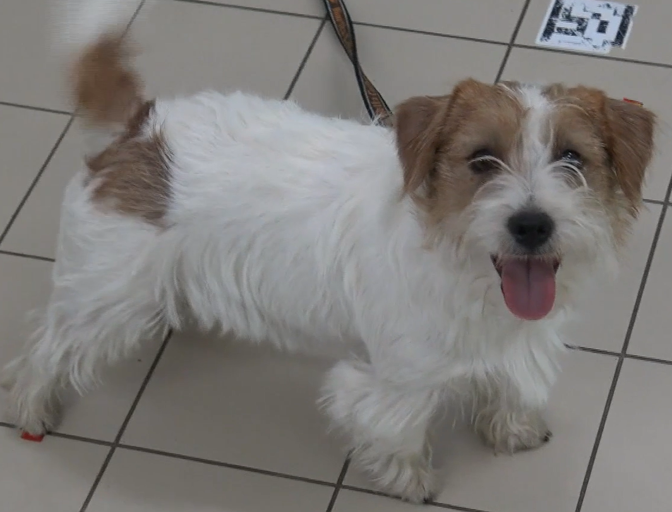
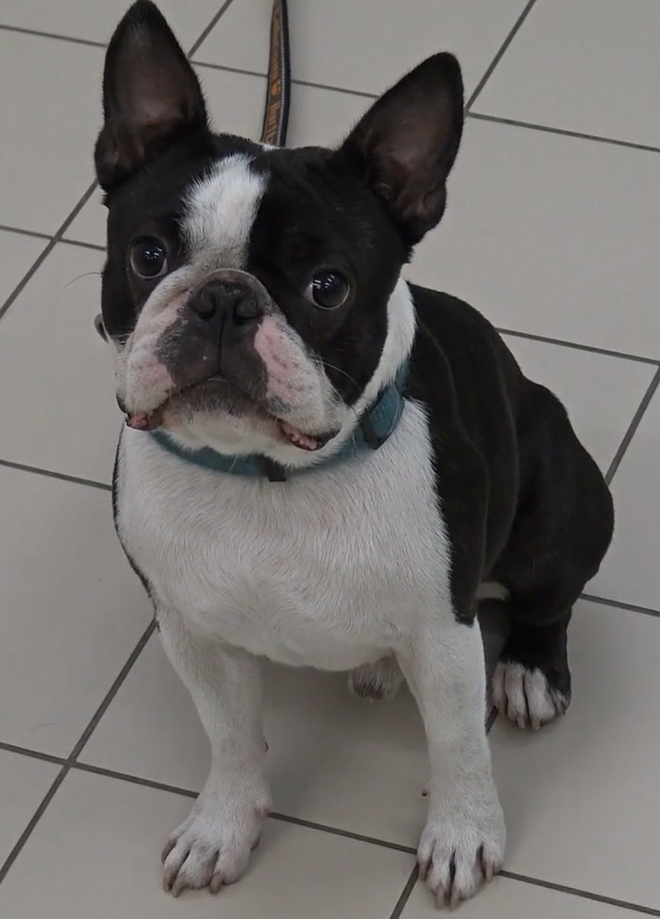
In the context of brachycephalic dogs, research has specifically examined how their facial structure influences their visual signals and how humans interpret these cues, encompassing both facial expressions and body language. However, it's important to note certain limitations within the existing literature [Eretová et al., 2024]. For instance, some studies may have varied participant demographics in terms of gender and age, potentially impacting the generalizability of the findings. Additionally, certain investigations may not have concentrated on a specific demographic or population subset, and sometimes, people do not report accurately or erroneously about the things they looked at, due to a variety of factors such as subconscious memory or external influences. All these could affect the depth of understanding in this area.

2.2. Dog’s Facial Reenactment
A study provided by [Bloom & Friedman, 2013] asserted that humans could ascertain emotions in other animals via both their facial and body expressions, using illustrations of a dog to demonstrate this claim.
How they examine:
- First of all, they examined whether three experts in dog behavior displayed significant concordance when ranking photographs of a dog's face taken under seven behaviorally defined conditions.
- Secondly, they examined whether non-experts could judge these expected emotional states of that dog and identify the emotion under which the photographs were taken.
- Third, they examined the differences between two groups of humans who had extensive experience with dogs and those who had little experience with dogs.
For the emotionality ratings, they presented a response sheet listing each basic emotion (i.e., Happy, Sad, Surprise, Disgusted, Angry, and Fearful) accompanied by a Likert-type scale (ranging from 0, indicating “None of this emotion present” to 4, indicating “As much of this emotion as possible is being displayed”). The interviewer asked them to select the correct situation for each of the 21 photographs, given the situations described on the response sheet.
Results:
They stated the expected emotion and the behavioral situation. Humans were able to accurately, but not perfectly, identify at least one dog's facial expressions. For example, data from both groups indicated that happiness was easily identifiable by all the human participants (Experienced 92%; Inexperienced 84%) integrated 88%. Percentages and accuracies of correctly categorized situations mean that the situation selected by the participant matches the situation the dog was experiencing.

A study provided by [Eretová et al., 2024] the study suggests that canine visual signals convey contextual and affective information to humans. However, the development of extreme features through artificial selection, such as brachycephaly, could hinder the efficacy of dogs’ visual signals. The researchers hypothesized that the shortened muzzle region of brachycephalic dogs may affect how human observers decipher a brachycephalic dog’s facial expressions.
What the study examines:
The study examined the ability of humans to interpret the visual signals and facial expressions of extremely brachycephalic (flat-faced) dogs, specifically Boston Terriers, and compared it with a normocephalic breed, Jack Russell Terriers.
Results:
The study found that the accuracy of contextual recognition depended on the type of source. Participants were generally more successful in recognizing ‘positive’ contexts (“Called by name”, “Play”) in the case of Boston Terriers, while ‘negative’ contexts (“Separation”, “Threatened by a stranger”) were more likely to be recognized in the case of Jack Russell Terriers. When comparing the valence of assigned contextual signals, Boston Terriers were more often assigned with ‘positive’ contexts based on video clips than on still pictures. No such difference was found in the Jack Russells. While evaluating the videos and pictures, participants were more likely to base their decision on the face and tail in case of the Jack Russells, but preferred to use the torso of the Boston Terriers for contextual information.

2.3. Eye Tracking Technology
Eye tracking technology is a sophisticated research tool that records and analyzes human eye movements, providing valuable insights into facial expressions, communication, and body perception. It is widely used in fields like psychology, neurology, and human-computer interaction, as well as human factors research and marketing. Eye tracking solutions include screen-based methods and wearable devices. However, effective use requires acquiring practical and methodological skills. Overall, eye tracking is a powerful tool for understanding human visual behavior [Majaranta & Bulling, 2014]. For our project, we'll use Tobii Pro Spark using eye-tracking metrics and imaging to gain deeper insights into participants' behavior and visual experiences (for example, see Fig. 3).
The eye-tracking methodology employed an integrated hardware and software approach, comprising an infrared camera to capture eye images, segmentation algorithms to detect the center of the pupil, auto-calibration procedures to map gaze points accurately, and stimulus control to identify regions of interest on the displayed map stimuli (for example, see Fig. 4).

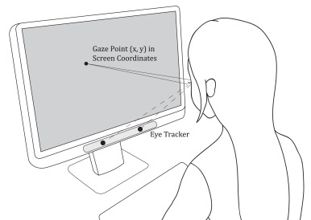

Fig. 3: How does screen-based eye-tracking work [Liu et al., 2021].

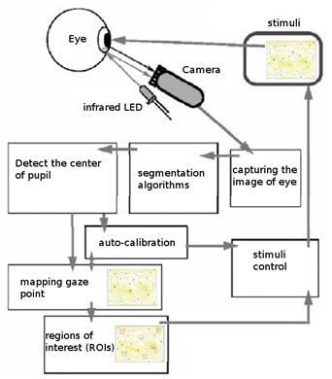
Fig. 4: Eye-tracking technology architecture.

2.4. Facial Reenactment Using Eye-Tracking Technology
We review some existing studies that tested the ability to identify facial expressions:
A study provided by [Hickson et al., 2019] describes the challenges of social interaction in VR, where VR masks hide a large part of the face and limit non-verbal communication. The authors present an algorithm that makes it possible to distinguish facial expressions by analyzing images of the user’s eyes, taken using the eye-tracking camera inside the VR mask. The authors also introduce an innovative method for collecting data and improving the CNN accuracy through customization.
The parameters tested in the study are:
- Fixations - prolonged views on specific areas of the face, such as the eyes, mouth, etc. Check the location, duration, and frequency of the fixations.
- Saccades - the rapid movements of the eye between fixation points. Check the trajectories of the saccades, their speed, and accuracy.
- Scan paths - the total paths of the eye movements across the face during the viewing of the expression. Check the scan path sequences and scan strategies.
- AOIs - defined areas on the face, such as the eyes, mouth, and forehead. Check the order of visit, length of stay, and return to the same AOIs.
- Dwell Times - The total amount of time the gaze stayed on different areas of the face.
- Visit Counts - the number of times the gaze visited different areas of the face.
Results:
The results show an average accuracy of 74% between 5 emotional expressions and an average of 70% between 10 different internal action units.
A study provided by [Bruckert et al., 2023] investigates the use of gaze and mouse tracking technology in the context of facial expression recognition. The research focuses on how a person's attention is directed when performing a facial expression recognition task.
The Methodology:
Eye movement data is collected through eye-tracking. Data on mouse movements, such as location and clicks, were collected. Participants classified their expressions into one of seven categories: anger, disgust, fear, joy, sadness, surprise, and neutral.
Stock includes: files that show the location and timing of eye and mouse movements. Files with participants' answers data on the expressions.
The parameters tested in the study are:
- Types of fixations that were checked:
  - duration of fixation - the average continuity of fixations on different areas inside the face (eyes, mouth, etc.) for every expression.
  - Counting fixations - Count the number of fixations on AOIs such as eyes and mouth, for different expressions.
  - Distribution fixations – The spatial distribution of the fixations on the face was tested to identify areas that attracted more/less attention to each expression.
- Types of saccades:
  - Amplitude saccades - Think of the distances of the saccades between the AOIs to learn about scanning patterns.
  - Saccades direction - the proportions of horizontal, vertical, and diagonal saccades between the expressions were compared.
  - Speed saccades - tested the speed of the saccades between the different features of the face.
- Facial features and AOIs:
The study segmented images into AOIs based on six facial features using semantic segmentation models. The distribution of gaze fixations showed significant differences, with eyebrow fixations higher in anger or surprise images.
Results:
The database provides a rich source of data for the study of human behavior and computer vision in the context of facial expressions. It enables the development of methods for analyzing patterns of eye/mouse movements for the identification of expressions.
The study offers an innovative approach to combining eye and mouse movement data for facial expression learning. Significant differences were found in parameters such as the average length of view, the number of clicks, and the mouse positions between the different expressions.

A study provided by [Iwauchi et al., 2023] used Tobii Pro Fusion and Tobii Pro Lab to analyze eye movements during tasks. Participants sat 65cm from the display, with AOIs set to eyes, mouth, and face for FEIT images. It analyzed eye-movement features, including fixations and saccades, to understand facial emotions.
The parameters tested in the study are:
- Fixation: It was found that people with higher autistic traits tended to have a shorter fixation on relevant areas of the face. They had more difficulty focusing their gaze for a long time on important points.
- Saccades: Individuals with autistic traits were different, with fewer saccades to central AOIs and greater deviations from relevant points.
- Accuracy: The study also found impaired accuracy of eye movements in people with higher levels of autism. They showed more overshoot and undershoot in making saccades to targets and less accurate fixation on important regions of interest.
- The eye movement path (Scan path): people with higher autistic traits presented different and less efficient scanning paths across the different visual stimuli.
- Time to AOIs: for people with higher autism, a longer time was needed for the initial arrival of important areas on the face or in the scene.
- Number of visits to AOIs: people with high autistic traits visited areas critical to performing the tasks less often.
- Dwell time in AOIs: there was a shorter time of prolonged stay in important areas.
Results:
The study demonstrates that using eye movement during VPT alongside facial emotion identification can enhance the prediction accuracy of autistic traits, suggesting a multidimensional evaluation of cognitive activities.

A study provided by [Correia-Caeiro et al., 2020] used an Eyelink 1000 Plus eye-tracker to analyze eye movements during the observation of dynamic facial expressions. Participants (humans and dogs) viewed video stimuli projected on a semi-translucent screen, with AOIs set to key facial regions such as eyes, mouth, nose, and cheeks. It analyzed gaze behavior features, specifically viewing time and gaze distribution, to understand inter-species emotion perception.
The parameters tested in the study are:
- Fixation (Viewing Time): It was found that human participants modulated their viewing time depending on the Area of Interest (AOI), the emotion displayed, and the species observed. In contrast, dogs modulated their gaze depending on the AOI only, suggesting a difference in how the two species prioritize visual information.
- Gaze Distribution: Humans showed a stereotypical gaze bias, allocating more attention to the eyes, followed by the nose and mouth. Dogs also preferred fixating on internal facial features, but their pattern was less affected by the specific emotional content compared to humans.
- Accuracy: Human participants were asked to identify the emotion observed (Emotion Categorisation Accuracy). The study highlighted that while humans apply specific strategies for human faces, they cannot often correctly interpret relevant subtle signals in dog facial expressions.
- The eye movement path (Scan path): The study analyzed the relationship between gaze and diagnostic facial movements (Action Units). For humans, eye movements were not correlated with the specific diagnostic movements of the expression. For dogs, there was only a partial relationship, suggesting that scanning facial expressions is a relatively automatic process.
- Dwell time in AOIs: The study measured the proportion of total viewing time directed at specific AOIs. Humans spent different amounts of time on AOIs based on the emotion (e.g., looking more at the mouth for positive emotions), whereas dogs did not show this specific modulation.
Results: The study demonstrates that humans and dogs show different gaze distributions when viewing the same facial expressions. Humans adapt their gaze strategy based on the emotion and species, while dogs rely on a more consistent scanning of specific facial areas regardless of the emotional context, implying different cognitive mechanisms for processing facial cues.
A study provided by [Guo et al., 2010] used a Video Eyetracker Toolbox (Cambridge Research Systems) to analyze eye movements during tasks. Participants (non-pet owners regarding the animal stimuli) sat 57cm from the display, with AOIs set to eyes, nose, and mouth for faces of humans, monkeys, dogs, and cats. It analyzed eye-movement features, including fixation distribution and sequential fixation placement, to understand spontaneous gaze patterns across different species.
The parameters tested in the study are:
- Fixation: It was found that faces of different species induced similar patterns of fixation distribution across local facial features. The eyes attracted the highest proportion of fixations (51-59%), followed by the nose (11-14%) and then the mouth (1-7%).
- Saccades (Gaze Bias): A consistent left gaze bias was observed during the initial stage of face exploration. The first saccade was directed at the left hemi-face (from the viewer's perspective) in 72-78% of the trials, regardless of the species viewed.
- Accuracy (Salience vs. Gaze): The study compared human gaze allocation to a computational saliency model (Itti and Koch, 2000). It found that gaze distribution, specifically the closer attention to human and monkey mouths, could not be accounted for by low-level image salience. The mouth regions in dogs and cats attracted significantly less attention than predicted by their saliency.
- The eye movement path (Scan path): The study analyzed the probability of sequential fixation placement for the first five fixations. It revealed that the differential gaze allocation to the mouth region (higher for humans/monkeys than for dogs/cats) was evident at the earliest stage of face viewing, specifically from the first fixation.
- Time to AOIs: The analysis showed that the species of the inspected face had a limited impact on the general allocation of viewing time across features, with the eyes always capturing the majority of time.
- Dwell time in AOIs (Viewing Time): Similar to fixations, the proportion of total viewing time was highest for the eyes. However, participants spent significantly less time viewing the mouth region of dogs and cats compared to humans and monkeys.
Results: The study demonstrates that spontaneous eye scanning patterns are mainly constrained by general facial configurations, as observers use a similar oculomotor strategy for different species. However, gaze allocation to the mouth is species-dependent and driven by semantic knowledge rather than simple image salience.

2.5. Summary
Although the literature review revealed many studies on different applications of eye-tracking technology and different parameters that were tested, most of them were concerned with human emotion recognition or relied on static imagery. Hence, understanding how humans perceive different dog breeds through gaze strategies, particularly breeds with extreme cranio-facial morphologies, remains limited.
Unlike previous work, which primarily utilized static images, the current study innovates by employing dynamic video stimuli to capture realistic, temporal gaze patterns. This methodological shift aims to provide objective measurements that contribute to a better understanding of the human-dog relationship and improve the human experience with canine behavior.

3. Research Process
Our project is a follow-up to another project conducted in 2024 under the supervision of our supervisor in collaboration with Prof. Anna Zamansky, Head of the Tech4Animals Laboratory at the University of Haifa, and a research team from the Czech University of Life Sciences in Prague, who conducted the initial study [Eretová et al., 2024]. The previous project looked at human perception of dog emotions, relying on static photographs. However, this approach is limited by the use of still images, which fail to capture the intrinsically dynamic nature of dog emotional expressions. Dog emotions develop over time through sequences of micro-expressions, postural changes, and contextual cues, requiring time-sensitive methods to capture their richness, so we will look at video.
As we delved into the realm of eye-tracking technology, we uncovered several works dealing with face and emotion recognition of humans. Next, we checked if there was similar research done in the field of face and emotion recognition of animals in general and dogs in particular. As a result of our learning, we progressed in understanding the dynamics of human-animal interaction, and we began delving into the mechanics of eye tracking systems, such as software applications like Tobii Pro Spark and Tobii Pro Lab, to understand their functionality and potential applications. Next, we defined the methodology we are going to use for our research: a controlled experiment. Consequently, we defined the experiment, including the data set based on the Czech experiment and the gaze tracking technology.
Going forward, we are going to develop a system equipped with an eye-tracker. This system will present videos featuring various breeds of dogs and ascertain the specific body/face areas the observer focuses on, along with the duration of their gaze. We will also explore whether individuals' proficiency in interpreting these signals is influenced by their experience with different dog breeds. The system will present observation results in diverse visual formats to enhance comprehension of the findings.
As part of the experimental procedure, we will provide a questionnaire, based on a previous study from which we draw inspiration. However, the questionnaire needs to be adapted to our needs for using eye-tracking technology. In addition, the questionnaire will need to be translated (into Hebrew).
Finally, we will analyze the results and conclude. This analysis will employ transition matrices to evaluate the sequential dynamics of gaze behavior and the probabilities of shifting attention between specific Areas of Interest (AOIs). To ensure reliable and accurate findings, potential limitations, such as environmental conditions, will be considered and mitigated as much as possible. Furthermore, meticulous attention will be paid to the experimental design, ensuring stages are executed sequentially according to scientific methodology, alongside the development of precise protocols and instructions for the participants. A more in-depth presentation of the research methodology is given in the next chapter.

4. Research Methodology
In our research, we plan to duplicate the experiment with the effect of brachycephaly on visual signals in dogs [Eretová et al., 2024] with the addition of eye-tracking technology that will record the participants' eye movements using dog videos. We aim to understand if looking at a certain area improves the understanding of the dog's behavior. Participants (we will recruit 40–50 participants, Braude College of Engineering students, in an evenly distributed age range, as well as in terms of participants' gender) will be given videos of brachycephalic and normocephalic dogs in various contexts, with the expectation that these dogs will display behaviors and facial expressions related to their inner states.

4.1. Stimuli
Our dataset consisted of a set of 8 videos from the experiment conducted by Eretová et al. (2024), which documented the behaviors of two dog breeds: Boston Terriers, representing brachycephalic dogs, and Jack Russell Terriers, representing normocephalic dogs. The study produced eight videos that focused mainly on the dogs' faces, following criteria that highlighted the best representation of each dog's behavior and desired expression in various situations. Images of the dog’s face included these dogs in one of these four situations:
- Situation 1 - Dog called by name (“Called”): Experimenter 1 called the dog by its name while Experimenter 2 recorded the dog's responses with a handheld camera.
- Situation 2 - Play (“Play”): The dog was instructed to play with a tennis ball while on a leash. Experimenter 1 presented the ball without giving it to the dog. Responses were recorded using both tripod and handheld cameras, ensuring that both the ball and Experimenter 1 remained hidden.
- Situation 3 - Separation (“Separation”): The owners left a dog in an experimental room for a brief examination, with Experimenter 1 present and the dog on a leash, maintaining a distance of at least 2 meters.
- Situation 4 - Threatened by a stranger (“Stranger”): Experimenter 2 threatened the dog by crouching, taking wide steps, and maintaining eye contact. Experimenter 1 captured the image while keeping Experimenter 2 out of the frame, and Experimenter 2 remained silent.
The stimuli were obtained in accordance with the guidelines for the use of animals in research, as outlined by the Association for the Study of Animal Behaviour (ASAB). The procedure was fully non-invasive. The methodology was reviewed and approved by the Animal Welfare Committee of Eötvös Loránd University (Certificate number PEI/001/1056–4/2015). Informed consent was obtained from every dog owner who participated in this part of the experiment.

4.2. Procedure
The experiments will be conducted in a quiet room, one participant at a time. The participants will be seated in front of a 24-inch screen using a full HD resolution of 1920x1080, about 65 cm from the display. We will use the Tobii Pro Spark with a sampling rate of 120 Hz to show the tasks (for example, see Fig. 3). After a welcome and a brief introduction to the purpose of the study, a short questionnaire containing personal information questions will be administered. Afterwards, the participants will proceed to the next part of the questionnaire, which includes an eye calibration part, and then viewing videos of dogs. They will have to answer for each video in what situation they think the dog is in (called by its name, play, being separated from their owners, or being threatened by a stranger) and choose which sentiment they believe the dog in this video is conveying (positive, negative, or neutral). Furthermore, participants will be required to indicate which areas of the dog's body or face they focused on to discern the dog's emotions and current state. During the viewing, eye analysis of the participants will be conducted using eye tracking technology, which will record eye movements and collect the data that will be utilized to algorithmically estimate a sequence of (x, y) participants' gaze point placements on the computer screen [Liu et al., 2021]. Once all the analyses are completed, the results will be saved for each video separately.

4.3. Hypothesis

We hypothesize that:
H1: Observers will spend more time examining videos of brachycephalic dogs compared to those of normocephalic dogs, reflecting the increased perceptual challenge posed by their altered facial morphology.
H2: We expect that the eye region will attract longer and more frequent fixations in brachycephalic dogs compared to normocephalic dogs.
H3: We anticipate that humans will attend to different AOIs, and in a different sequence, depending on the breed being observed, revealing breed-specific perceptual strategies in the interpretation of canine facial cues.

4.4. Experimental Parameters
The parameters we want to examine in our experiment, which will assist us in our research, are:
- DAOIs (Dynamic Areas of Interest): Areas of interest that change over time based on the dynamic movement or behaviors of the dog in the video.
- Fixation [Guo & Shaw, 2015; Sæther et al., 2009], including duration of fixation [Guo & Shaw, 2015] and number of fixations.
- Saccades: amplitude saccades (describes the distance the eye moves from point to point), including saccade direction [Sæther et al., 2009].
- Scan paths: refer to the sequence of fixations and saccades, showing the order in which areas are viewed and how gaze transitions between them.
- Proportions of fixations are directed at a specific area of the dog [Sæther et al., 2009] (this gives an indication if focusing on a specific AOI provides a more accurate answer [Eretová et al., 2024]).
- TOI mean for how long did they look? [Guo & Shaw, 2015].

The selection of the parameters for this study was based on a comprehensive review of previous studies and relevant articles in the field. Special emphasis was placed on locating the most common and accepted indices for examining eye movements and visual coding processes, as these are expected to provide the most reliable and significant data for the needs of the current study. At the same time, it was decided not to include parameters that have been identified as less relevant to the research question and the hypotheses that have been put forward in order to focus efforts on the indicators that are expected to yield the most significant results.

4.5. Gaze Transitions Among AOIs

4.5.1. Gaze Transition Analysis and Matrix Generation:
To understand the temporal dynamics of the participants' visual behavior, we will move beyond static fixation counts and analyze the Scan Path - the sequential order in which participants view different areas of interest (AOIs). This analysis will be performed by generating and analyzing Gaze Transition Matrices.

4.5.2. Methodological Approach and Algorithm:
Our proposed algorithm for analyzing scan paths will follow a data-driven pipeline implemented in Python. The process treats the raw data processing as a modular component, designed to transform continuous gaze signals into discrete transition events.
- Input: The system will ingest raw eye-tracking data files (CSV format) containing timestamped gaze coordinates.
- Processing: Similar to the gaze sample processing logic described in Algorithm 1 of Iwauchi et al. (2023), (see Fig. 5), we will iterate through valid gaze samples to identify fixation sequences. The algorithm will map these fixations to specific AOIs to determine the "state" of the viewer at any given moment.
Fig. 5: Pseudo Code of scan path length algorithm
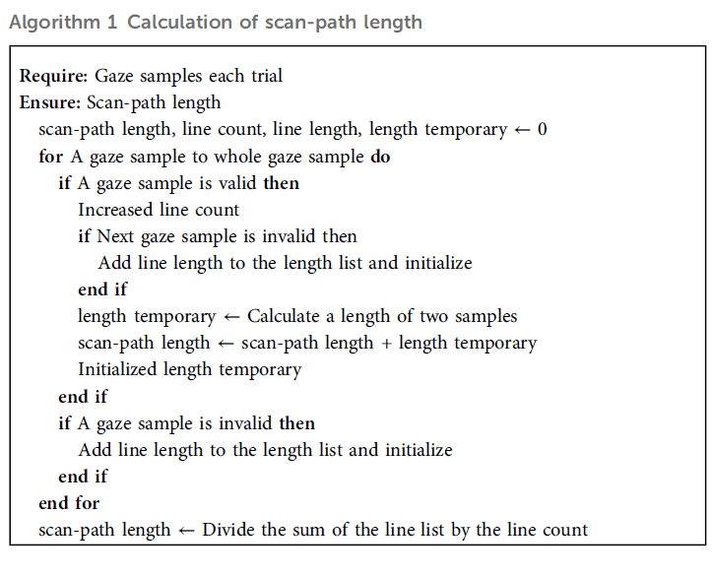
Output: The final output will be a Transition Matrix, representing the probability of gaze shifting from one specific AOI to another. This visualization format is adopted from the methodology presented by Raptis et al. (2017), which utilizes grey-scale matrices to depict transition probabilities between vertical AOIs. (see Fig. 6.)
Fig. 6 - Transition matrix in grey from Raptis et al. (2017)
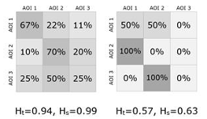

4.5.3. Understanding the Transition Matrix
The transition matrix provides a statistical representation of the viewing sequence. It is constructed as a square matrix where:
- The Vertical Axis (Rows): Represents the Source AOI - the area where the gaze was initially fixed (time t).
- The Horizontal Axis (Columns): Represents the Destination AOI - the area where the gaze moved to immediately following the initial fixation (time t+1).
Each cell (i, j) in the matrix contains a value (percentage or probability) indicating how frequently the participant shifted their gaze directly from AOI i to AOI j. This allows us to identify specific loops, repetitive checking behaviors, or linear scanning patterns.

4.5.3.1. Exploratory AOI Grouping Strategy
To ensure we capture the most meaningful behavioral patterns, we will not limit the analysis to a single set of AOIs. Instead, we will implement an iterative "export and analyze" strategy to determine which level of granularity yields the most valuable feedback. We plan to generate matrices based on different AOI configurations:
- High Granularity: Calculating transitions between every individual AOI separately (e.g., Left Eye, Right Eye, Snout Area, Torso, Right Leg, Left Leg, etc.).
- Semantic Grouping: Aggregating related features into functional groups. For example, combining "Left Eye," "Right Eye," and "Forehead" into a single "Upper Face" cluster, vs. a "Lower Face" cluster.
- Macro-Level Division: testing broad divisions, such as a binary split between "Head/Face" and "Body/Limbs".
By comparing the transition matrices generated from these different configurations, we aim to discover which spatial division reveals the most distinct and statistically significant scan-path patterns between the study groups.

4.6. Tools and Technologies
To summarize, the following tools and technologies will be used throughout the project, as illustrated in Fig. 7.
- Development Environment: We will utilize Python as the primary programming language due to its robust data analysis capabilities. Key libraries such as Pandas and NumPy will be used to ingest and structure the raw eye-tracking data imported from CSV files.
- Algorithmic Implementation: We will implement a custom processing algorithm designed to parse raw gaze signals. This includes identifying fixations and saccades and mapping these coordinates to specific Areas of Interest (AOIs) to calculate the gaze scan paths.
- Data Visualization: To interpret the results, we will employ libraries like Matplotlib and Seaborn. These will be used to generate statistical plots and render the Gaze Transition Matrices, allowing us to visualize the probability of gaze shifts between different AOIs.
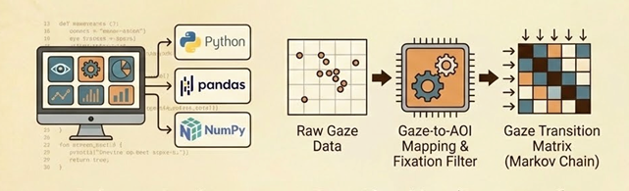
Fig. 7: Tools and Technologies.

4.7. Expected Challenges and Successes
Throughout the development and research phases, we encountered several challenges, including technical, logistical, and methodological ones. Below, we detail these hurdles and the specific solutions employed or planned to overcome them.

4.7.1. Laboratory Setup, Licensing, and Environmental Control
- Challenge: The project faced significant logistical and technical hurdles regarding both the physical testing environment and the software infrastructure. On the technical front, we encountered persistent compatibility issues with Tobii Pro Lab; the specific license keys provided by the college were incompatible with the versions installed on the lab computers. We initially relied on a trial version, but its expiration caused access disruptions, and the default lab installations required repeated updates to match our project requirements. Physically, the initial workstation placement was suboptimal due to lighting glare from windows and an uncomfortable seating angle, which threatened the quality of the gaze recording.
- Solution: We addressed these issues through a multifaceted approach. To resolve the software conflicts, we coordinated with the college administration and the IT department to identify the precise software build compatible with our academic license and standardized this version across the lab machines, ensuring long-term stability. Simultaneously, we optimized the physical testing environment by relocating the workstation to an area with controlled artificial lighting, eliminating direct sunlight glare and establishing a comfortable, distraction-free seating arrangement to ensure high-quality gaze data collection.

4.7.2. Data Preparation and Manual Mapping
- Challenge: Preparing the video stimuli for the experiment required frame-by-frame mapping, which proved to be a time-intensive and labor-heavy process. Working in pairs, each team member was responsible for mapping 4 videos, totaling approximately 1,000 frames each. This required constant manual adjustment of dynamic Areas of Interest (AOIs) to track the moving dogs accurately.
- Solution: To manage this workload, we optimized our workflow through trial and error, specifically focusing on the initial definition of AOI polygons. We discovered a critical trade-off regarding the number of vertices (points) used to define an area:
  - Vertex Density Balance: Using too few vertices (e.g., only 5 points for the torso) limited our ability to accurately reshape the AOI as the dog moved, whereas using too many vertices made frame-by-frame adjustments tedious and inefficient. We learned to establish an optimal balance using enough points to allow precise contouring without creating unnecessary workload.
  - Bulk Manipulation: We accelerated the process by utilizing software capabilities for bulk adjustments. For instance, when the dog moved linearly (e.g., strictly left or right), we translated the entire AOI polygon as a single unit rather than moving individual points. Additionally, we utilized multi-point selection to adjust specific edges simultaneously. These techniques, combined with mastery of keyboard shortcuts, significantly increased our mapping speed while maintaining high experimental precision.

4.7.3. Participant Recruitment
- Challenge: Recruiting a sufficient sample size of 40-50 participants for the experiment is anticipated to be a significant logistical challenge, given the time commitment required from volunteers.
- Solution: To mitigate this, we plan to utilize a multi-channel recruitment strategy. We will enlist the support of our supervisors, Julia and Samah, to reach a broader audience. Additionally, we will actively recruit peers from the software engineering department and university acquaintances, encouraging participation to meet the required sample size.

4.7.4. Data Analysis and Algorithmic Implementation
- Challenge: We anticipate that analyzing the raw eye-tracking data and developing the Python code to generate the transition matrices will be complex. Handling raw CSV exports and converting them into meaningful visual patterns requires precise logic.
- Solution: We intend to approach this challenge through collaborative problem-solving. By uniting our efforts and brainstorming the logic together, we aim to develop an optimal algorithm that accurately processes the gaze paths and produces reliable feedback matrices.

GenAI Usage Discloser
During the preparation of this work, the authors used Gemini and ChatGPT to enhance language and grammar. After using this service, the authors reviewed and edited the content as needed and took full responsibility for the content of the published article.

References
- Bek, J., Poliakoff, E., & Lander, K. (2020). Measuring emotion recognition by people with Parkinson’s disease using eye-tracking with dynamic facial expressions. Journal of Neuroscience Methods, 331, 108524.‏
- Bloom, T., & Friedman, H. (2013). Classifying dogs’(Canis familiaris) facial expressions from photographs. Behavioural processes, 96, 1-10.‏
- Bruckert, A., Lévêque, L., Perreira Da Silva, M., & Le Callet, P. (2023, June). A Dataset of Gaze and Mouse Patterns in the Context of Facial Expression Recognition. In Proceedings of the 2023 ACM International Conference on Interactive Media Experiences (pp. 157-164).‏
- Correia-Caeiro, C., Guo, K., & Mills, D. S. (2020). Perception of dynamic facial expressions of emotion between dogs and humans. Animal cognition, 23(3), 465-476.‏
- Correia‐Caeiro, C., Lawrence, A., Abdelrahman, A., Guo, K., & Mills, D. (2023). How do children view and categorise human and dog facial expressions?. Developmental Science, 26(3), e13332.‏
- Eretová, P., Liu, Q., Přibylová, L., Chaloupková, H., Bakos, V., Lenkei, R., & Pongrácz, P. (2024). Can my human read my flat face? The curious case of understanding the contextual cues of extremely brachycephalic dogs. Applied Animal Behaviour Science, 270, 106134.‏
- Guo, K., & Shaw, H. (2015). Face in profile view reduces perceived facial expression intensity: an eye-tracking study. Acta psychologica, 155, 19-28.
- Guo, K., Tunnicliffe, D., & Roebuck, H. (2010). Human Spontaneous Gaze Patterns in Viewing of Faces of Different Species. Perception, 39(4), 533–542.
- Hickson, S., Dufour, N., Sud, A., Kwatra, V., & Essa, I. (2019, January). Eyemotion: Classifying facial expressions in VR using eye-tracking cameras. In 2019, IEEE Winter Conference on Applications of Computer Vision (WACV) (pp. 1626-1635). IEEE.‏
- Itti, L., & Koch, C. (2000). A saliency-based search mechanism for overt and covert shifts of visual attention. Vision Research, 40(10-12), 1489–1506.
- Iwauchi, K., Tanaka, H., Okazaki, K., Matsuda, Y., Uratani, M., Morimoto, T., & Nakamura, S. (2023). Eye-movement analysis on facial expression for identifying children and adults with neurodevelopmental disorders. Frontiers in Digital Health, 5, 952433.‏
- Liu, W., Trapp, A. C., & Djamasbi, S. (2021). Outlier-Aware, density-Based gaze fixation identification. Omega, 102, 102298.‏
- Majaranta, P., & Bulling, A. (2014). Eye tracking and eye-based human–computer interaction. In Advances in physiological computing (pp. 39-65). London: Springer London.‏
- Raptis, G. E., Katsini, C., Belk, M., Fidas, C., Samaras, G., & Avouris, N. (2017). Using eye gaze data and visual activities to infer human cognitive styles: method and feasibility studies. Proceedings of the 25th Conference on User Modeling, Adaptation and Personalization, 164–173.
- Raschke, M., Blascheck, T., & Burch, M. (2014). Visual analysis of eye tracking data. Handbook of human centric visualization, 391-409.‏
- Sæther, L., Van Belle, W., Laeng, B., Brennen, T., & Øvervoll, M. (2009). Anchoring gaze when categorizing faces’ sex: evidence from eye-tracking data. Vision research, 49(23), 2870-2880.

https://www.oakhill-vets.com/small/brachycephalic-dog/
https://www.tobii.com/products/eye-trackers/screen-based/tobii-pro-spark

